DIGITAL MARKETING

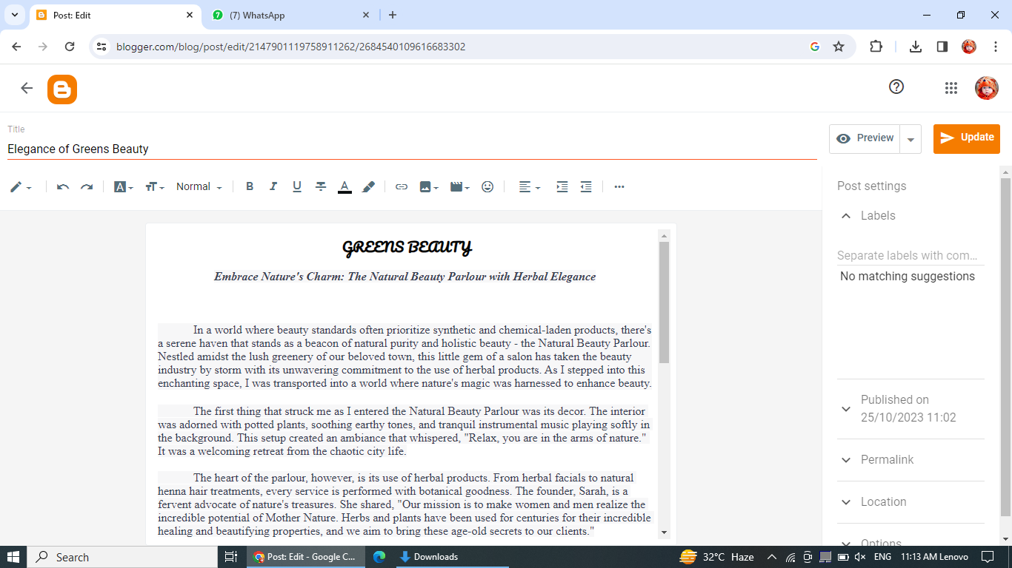Assignment 1- Creating a blog Customizing the theme design and posting a new article with 500 words

Blogger link :

<https://www.blogger.com/blog/post/edit/2147901119758911262/2684540109616683302>

Passage

**GREENS BEAUTY**

***Embrace Nature's Charm: The Natural Beauty Parlour with Herbal Elegance***

            In a world where beauty standards often prioritize synthetic and chemical-laden products, there's a serene haven that stands as a beacon of natural purity and holistic beauty - the Natural Beauty Parlour. Nestled amidst the lush greenery of our beloved town, this little gem of a salon has taken the beauty industry by storm with its unwavering commitment to the use of herbal products. As I stepped into this enchanting space, I was transported into a world where nature's magic was harnessed to enhance beauty.

            The first thing that struck me as I entered the Natural Beauty Parlour was its decor. The interior was adorned with potted plants, soothing earthy tones, and tranquil instrumental music playing softly in the background. This setup created an ambiance that whispered, "Relax, you are in the arms of nature." It was a welcoming retreat from the chaotic city life.

            The heart of the parlour, however, is its use of herbal products. From herbal facials to natural henna hair treatments, every service is performed with botanical goodness. The founder, Sarah, is a fervent advocate of nature's treasures. She shared, "Our mission is to make women and men realize the incredible potential of Mother Nature. Herbs and plants have been used for centuries for their incredible healing and beautifying properties, and we aim to bring these age-old secrets to our clients."

            During my visit, I opted for their signature "Herbal Radiance Facial." Sarah's skilled hands and the use of a blend of herbs, including neem, aloe vera, and turmeric, made my skin feel revitalized. I could sense the natural ingredients working their magic as I reveled in the fragrant aromas and soothing textures. The experience was a far cry from the sometimes harsh and chemically-laden facials I had received elsewhere.

            The Natural Beauty Parlour's commitment to sustainability is commendable as well. All of their products are sourced locally, reducing their carbon footprint, and they employ eco-friendly packaging. They have even gone a step further by actively promoting the concept of "farm-to-face" by partnering with local herb farmers.

            After my rejuvenating facial, I had the privilege of talking to Sarah about the parlour's philosophy. "Our approach is not just about making people look beautiful," she said, "it's about making them feel beautiful from the inside out. When you use natural, herbal products, it's a gentle reminder that we are all a part of this beautiful, natural world."

            The Natural Beauty Parlour offers an array of services, from herbal hair dyes that leave you with glossy, toxin-free locks to relaxing herbal body massages that melt away stress. They even have an in-house herbal apothecary where clients can purchase the herbal elixirs used during their treatments.

            My visit to the Natural Beauty Parlour was nothing short of enchanting. In a world often obsessed with quick fixes and chemical beauty, this salon serves as an oasis of natural grace and elegance. It's a place where beauty is redefined as a harmonious relationship between oneself and the world around us.

            As I left the parlour, my skin glowing and my heart uplifted, I couldn't help but smile. The Natural Beauty Parlour is not just a salon; it's a movement, a tribute to the power of nature and a celebration of our organic selves. In a world that often forgets its roots, this hidden gem is a beautiful reminder that true beauty can be found in the embrace of nature's charms.